For The People

# Title Page

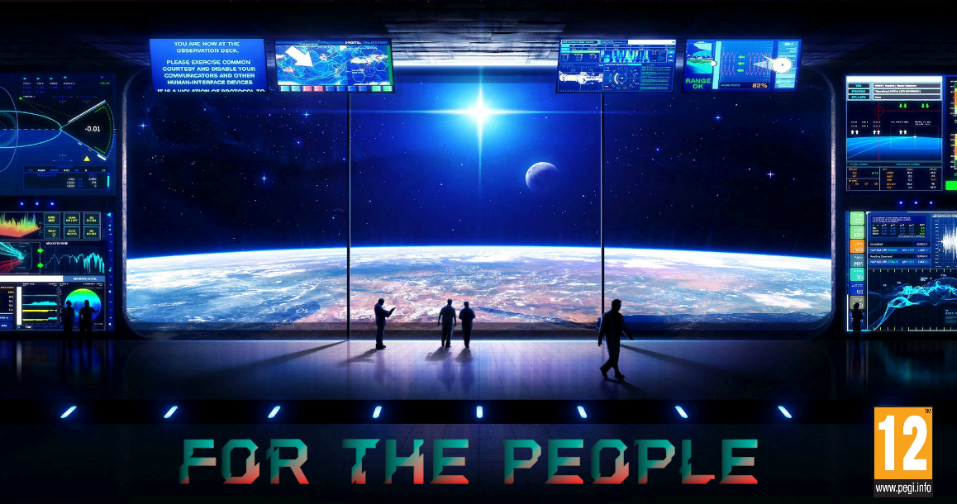

# Story and Gameplay

Initially in For The People, the player will be placed into the shoes of Admiral Zethanax Kril, with the sole mission of expanding the Klorax empire. After countless months aboard his ship, The HMX Eclipse, Admiral Kril and the player will discover a suitable world for colonization.

The player will now be presented with choices to decide if this planet will be suitable. Through choices such as:

* Reading the ship’s database
* Examining and scanning the planet
* A conversation with your 2nd in command

You will decide whether or not to send the expeditionary team or fly back amongst the stars.

Granted the player chooses to explore the jungle planet of Erith (Earth), the crew will make various dangerous and horrifying discoveries such as:

* Hostile atmosphere
* Ample doses of radiation
* Mutated humanoids

If or when the player reaches the third stage of the game, the player character will order a temporary camp to better assess the liveability of Erith.

During the first night of the expedition the camp will be attacked by hostile local lifeforms. These bipedal, semi sentient and violent creatures will resemble what once was humanity before atomic evolution changed the planet as we know it.

Once the player is captured Admiral Kril and Lieutenant Kael must escape the creatures’ camp. The outcome of the story depends on the actions that occur once captured. The player must choose wisely to protect themselves, their crew and their mission.

# Character(s) and Controls

Admiral Kril can be cold, calculating, and driven by a desire to prove himself, however in the heat of battle, his compassion for his subordinates can be seen with even the lowest casualty reports. On the surface he may seem distant and changed from his earlier cheery self but that is just the tired man, sick of death and war. Ambitious as always his head is forever in the stars, ready to subjugate or establish new worlds for the Klorax Royals.



# Main Concepts and Platform Specific Features

The primary mechanic of For The People is the choice system that appears on screen during the dialogues. The player can select their desired choice by pressing the left mouse button whilst the cursor is on their choice.

For the People would be suitable for mobile adaptation. With minor tweaks it's relatively low spec requirements make it suitable for mobile platforms.

# Game World

For The People takes place thousands of years in the future after modern day humanity has sent themselves back to the stone age via nuclear winter.

* Some of the visitable areas are:
* The HMX Eclipse. Scout ship for the Klorax Empire.
* An abandoned Temple. Really it is a nuclear plant the crew has mistaken for a cult of atomic energy.
* The jungles of Erith. The crew must navigate through thick Bush to uncover the planters mysteries.
* The Exploration Camp. Set up by the Expeditionary force.
* Barbarian Camp. Get taken by the abominations that inhabit the desolate rock.
* The locations are all visited through the branching narrative. Player choices directly impact where they will end up.

# Interface

The user interface on For The People is navigable via the mouse. It is a very simple point and click style menu system that works well with the visual novel.

The music choices were chosen to amplify the emotions in the scenes. Inspiring upbeat music once Erith was discovered  and if the Expeditionary team acquired artefacts from the temple. Similarly the music inspires fear and suspense in the barbarian Camp and during the hostile encounter in the jungle.